# Characteristics of the Graph of the Parent Function $f\left(x\right)=b^{x}$

An exponential function with the form $f\left(x\right)=b^{x}$, $b>0$, $b≠1$,

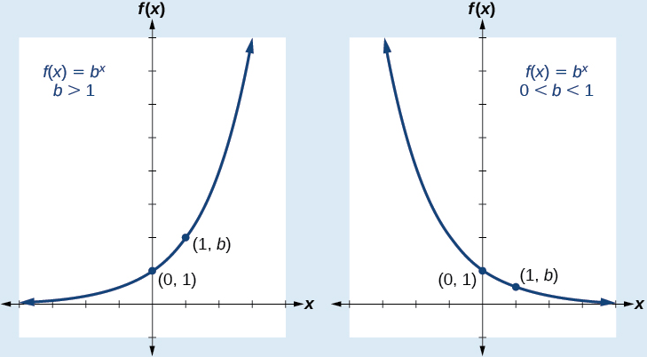

has the following characteristics:

One-to-one function

Horizontal asymptote: $y=0$

Domain: $(-∞, ∞)$

Range: $(0, ∞)$

$x$-intercept: none

$y$-intercept: $(0,1)$

Increasing if $b>1$

Decreasing if $0<b<1$

Examples: For each of the following, sketch a graph of the function and then state the domain, range, and asymptote.

$f\left(x\right)={\left(0.25\right)}^{x}$

$f\left(x\right)=4^{x}$

Transformations of exponential graphs behave similarly to those of other functions. Just as with other parent functions, we can apply the four types of transformations—shifts, reflections, stretches, and compressions—to the parent function $f\left(x\right)=b^{x}$ without loss of shape.

# Graphing Transformations of Exponential Functions

A translation of an exponential function has the form

$$f\left(x\right)=ab^{x±c}±d$$

Where the parent function, $y=b^{x}$, $b>1$, is

Reflected across the $x$-axis when $a<0$

Stretched vertically by a factor of $\left|a\right|$ if $\left|a\right|>1$

Compressed vertically by a factor of $\left|a\right|$ if $\left|a\right|<1$

Shifted horizontally $c$ units

Shifted vertically $d$ units

Note the order of the shifts, transformations, and reflections follow the order of operations.

Examples

1. Graph $f\left(x\right)=2^{x+1}-3$. State the domain, range, and asymptote.

1. Write an equation for the function described below. Give the horizontal asymptote, the domain, and the range.

$f\left(x\right)=e^{x}$ is compressed vertically by a factor of $\frac{1}{3}$, reflected across the $x-$ axis, and shifted down 2 units.